**EXPERIMENT-8**

**Submitted by:**Ajay Kumar Tyagi  
500067403  
R171218008  
CSE-DevOps 2018-2022

**Aim:** To create Docker swarm cluster.

**Procedure:**

**1)** Use command **docker swarm init** on a node to initialize it as master node.  
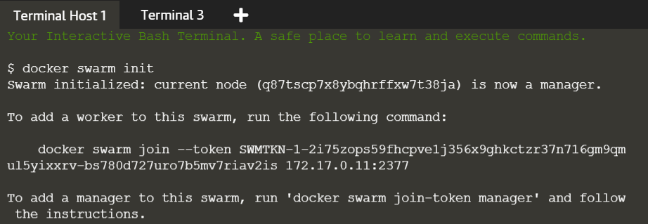

**2)** Copy this docker swarm join --token command and run it on the another node to join it in the swarm clusterand configure it as worker node.

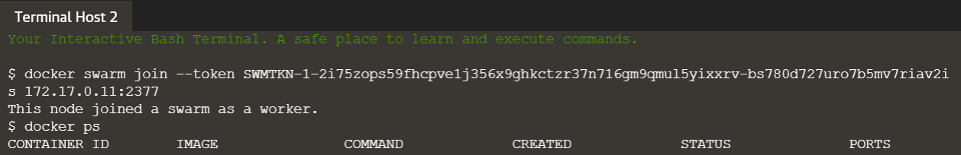

**3)** On the master node run command docker node ls to see all the nodes that have joined the swarm cluster.  
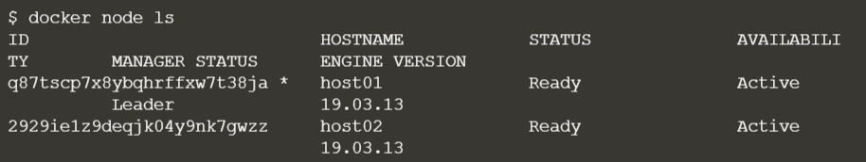

**4)** To create an overlay network via swarm manager node, use command **docker network create -d overlay app1-network**.  
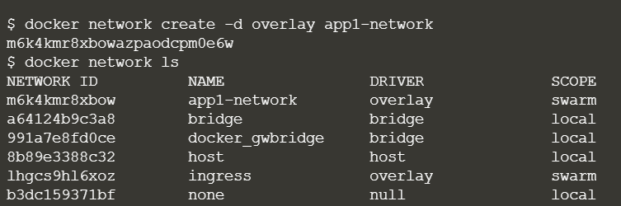

**5)** To create a service, use command  
**docker service create --network <network-name> -p <port-forwading> --replicas <replicas> --name <service-name> <image-name>.**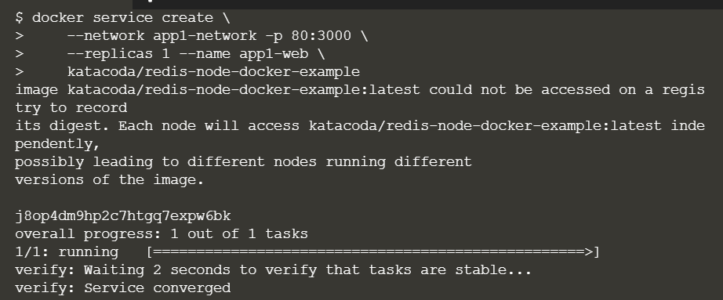

**6)** Use command docker service ls to check all the services running.  
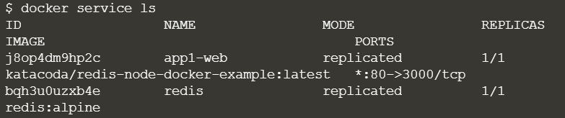

**7)** Use command **docker service ps <service-name>** to check the state of the service.  
